

Meals Me App

Karam Abd | Android Programming | 12-04-2020

Contents

The purpose Meals Me App: 2

The target users for Meals-Me App: 2

The Functionality of The App: 2

Technical design: 3

Class Diagram: 3

Wireframing description: 5

Functional design: 6

User Manual: 8

Conclusion: 14

# The purpose Meals Me App:

Meals me app idea is to help you make use of any cooking item of vegetables, oil, spices and seeds to advice you with a meal based on what you have at home.

## The target users for Meals-Me App:

* People with few knowledges about cooking.
* People who suffer from poverty and have limited access to specific items.
* People who allergic from items they can find meals by deselecting items.

## The Functionality of The App:

The user will select – deselect items existed at his/her place to get back a result of meals can be served or cooked with these items. It offers also other functionalities:

* Supports both Arabic and English languages (English is the default language).
* Sorting by item type (Vegetables, Fruits, Seeds, Oils and Milk types).
* Sorting by cold/warm meals.
* Sorting by Duration, Calories, and Name.
* Updating a meal
* Search for items
* Recommendation for meals based on what you select of items.

# Technical design:

## Class Diagram:

|  |
| --- |
| **User** |
| username: String  meals: ArrayList<Meal>  recommendedMeals: ArrayList<Meal>  recentMeals: ArrayList<Meal>  items: ArrayList<Item> currentSelectedMeal: Meal  language: String |
| User(String)  setUsername(String):void  getRecentMeals(): ArrayList<Meal>  addToRecentMeals(Meal): void  setCurrentSelectedMeal(Meal): void  getCurrentSelectedMeal(): Meal  setLanguage(String): void  getLanguage(): String  getUsername(): String  getItems(): ArrayList<Item>  updateItems(): void  getAllMeals(): ArrayList<Meal>  checkIfNameExisted(Meal): boolean  checkIfNameExistedStr(String): boolean  addMeal(Meal):Boolean  getMealByName(String): Meal  getItemByName(String): Item  getAllRecommendedMeals(): void  getRecommendedMeals(): ArrayList<Meal>  filterRecommendedMeals(String): void  getSelectedItems(): ArrayList<Item>  getUnSelectedItems(): ArrayList<Item>  setAllItemsUnSelected(): void  setAllItemsSelected(): void  selectItemByName(String): void |

|  |
| --- |
| **Meal** |
| mealName: String  items: ArrayList<Item>  description: String  image: int  durationInMinutes: int  isSelected: boolean dateCreated: Date |
| Meal(String, String, int, int)  Meal(String, String, int)  Meal()  setMealName(String): void  setDescription(String): void  setItems(ArrayList<Item>): void  setDurationInMinutes(int): void  addItem(Item): void  getMealName(): String  getDescription(): String  getDurationInMinutes(): int  getItems(): ArrayList<Item>  setImage(int): void  getImage(): int  getDateCreated(): Date  setDateCreated(Date): void  MealNameComparator(): Comparator<Meal>  MealCaloriesComparator(): Comparator<Meal>  MealDurationComparator(): Comparator<Meal> |

|  |
| --- |
| **Item** |
| itemName: String  description: String  calories: int  picture: int  isVegan: boolean  isVegetarian: boolean  isCarnicore: boolean  isSelected: boolean |
| Item(String, String, int, int, int, boolean, boolean, boolean)  Item(String, String, int, int, int, boolean, boolean, boolean, boolean)  getDescription(): String  isVegan(): boolean  isVegetarian(): boolean  isCarnivore(): boolean  getItemName(): String  getPicture(): int  getCalories(): int  isSelectedChange(): void  isSelected(): boolean  unSelectedChange(): void  selectedChange(): void  compareTo(Item): int |

## Wireframing description:

The idea of the app came to me from a daily issue I face everyday, I start thinking simulating how I thing when I want to cook something, I start thinking what I have already at home of items, them my brain thinks of meals I already know, but then I thought of a question, what if I have a dictionary of all meals in my brain, would it be a problem for me to prepare meals even with small number of items, I then I thought of applying this idea into an app, and I was also interviewing my friends about the idea and how would it help them, they were happy about having such an app in their phone, specially those who left their homes to live alone. I start designing the app process exactly how I processes it in my brain. First page that holds the preferred meals (or recently visited meals) in our case, then a screen to collect items, then a screen to show the recommended meals, I also thought of having a sort, so people who prefer to have meals with less duration, calories, and for those who would love to see seek meals they have heard about it. Then a screen to show the details of the meal to be prepared. I also thought about editing meals based on the user preference, people may remove items such us salt, sugar or any thing else. Or even update the name of the meal, and the description. I used a virtual machine “Pixel 2 API 29” and my cell phone “Samsung S10 plus”.

# Functional design:

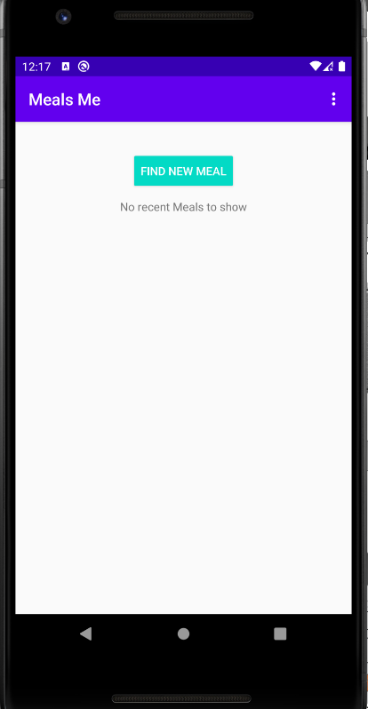

MainActivity

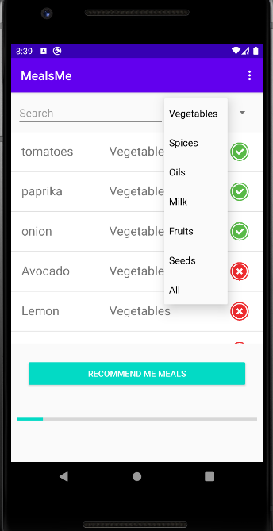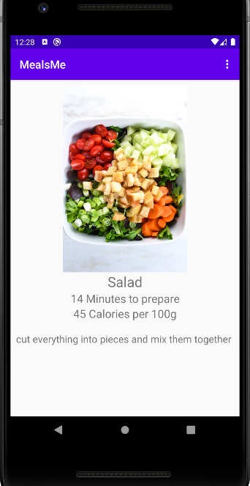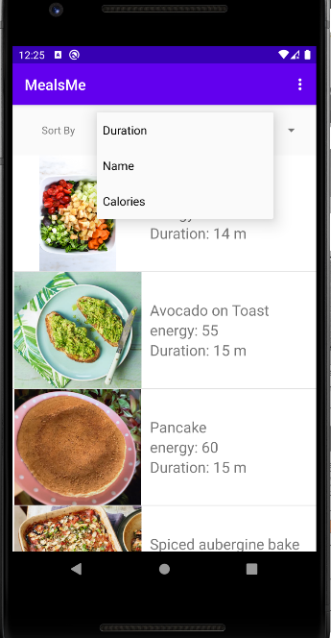

MealDetailsActivity

RecommendedMeals

ItemListView

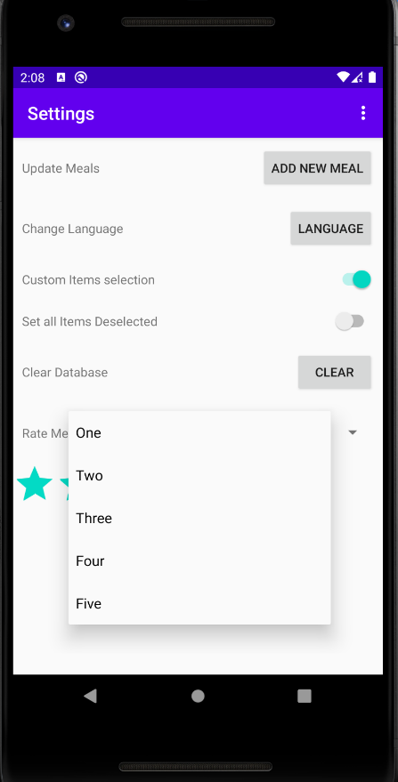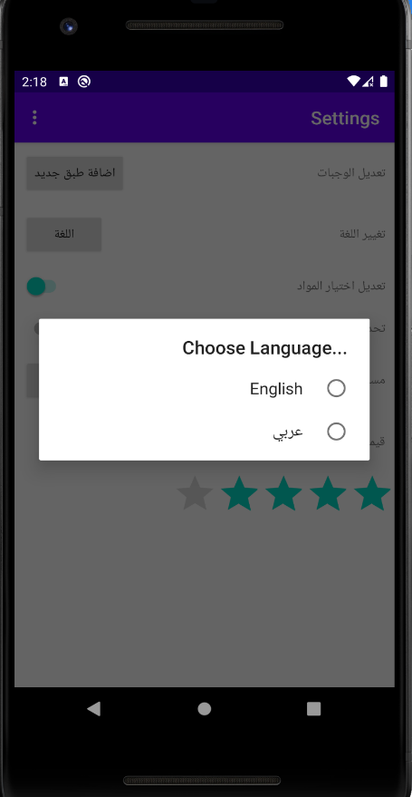

**SettingsActivity**

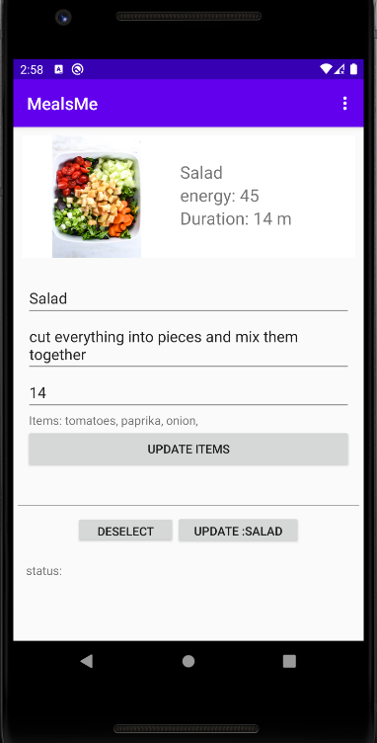

**AddMeal**

# User Manual:



1- Main Application Screen:

This screen will appear to you once you click on the icon of the app in the apps list in your phone, it contains a button to start looking for a meal, and a list contains the recent visited meals. It also contains a menu in the nav bar of the screen in the up-right corner that will take you to the application settings. See picture (1).

**1-**

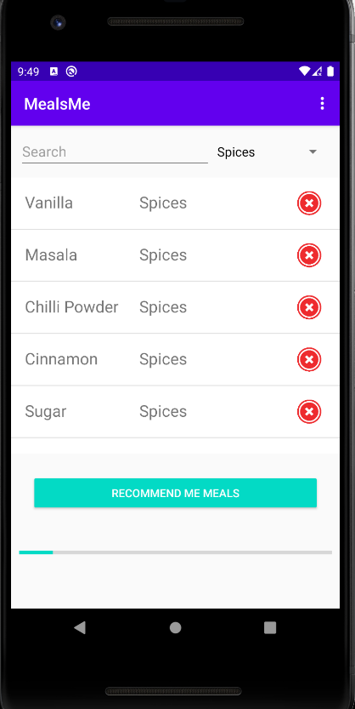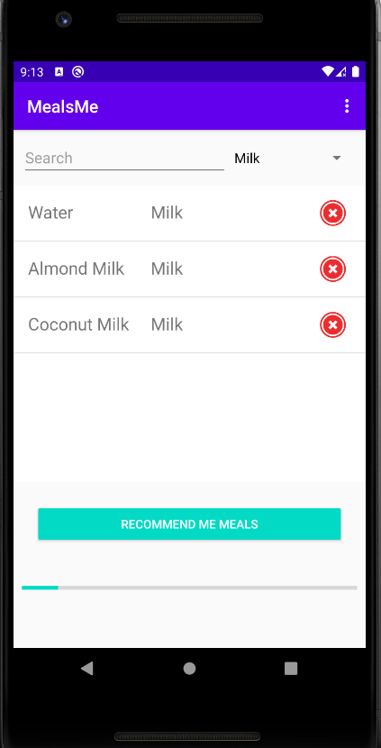

**4**

**3**

**2**

After pressing the button “FIND NEW MEAL”, you will find yourself in the screen where you start selecting the items you have, and you can filter those items as written in picture (2), also you can search for an item by start typing the item name, with every letter you write, you will get on real time results. The pictures (3,4) are showing the results when you select to filter between items. The custom drawing in the bottom of the screen shows the selected items progress, in simple English: how many items you’ve selected compared of the over all items.

**7**

**6**

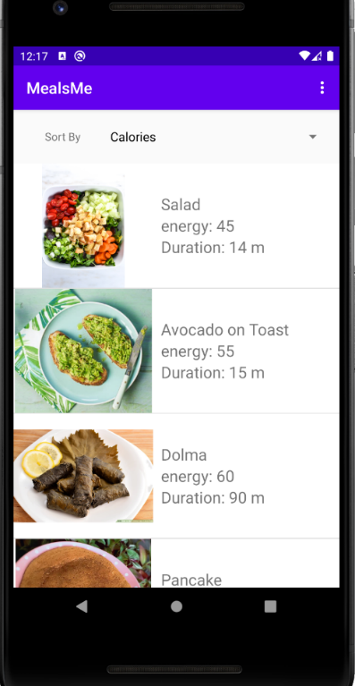

**5**

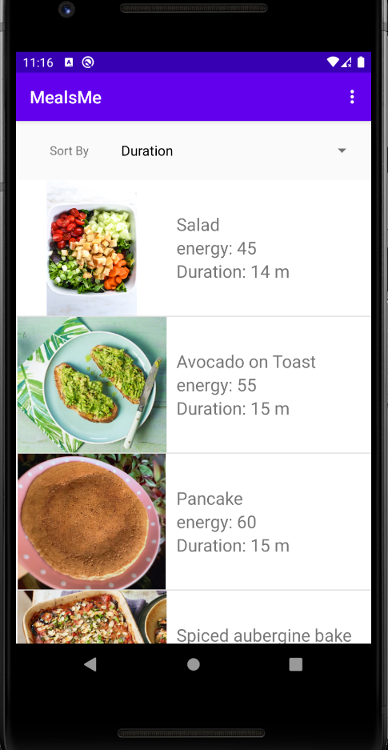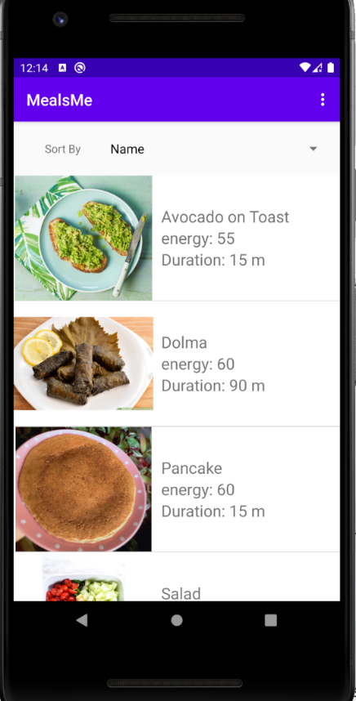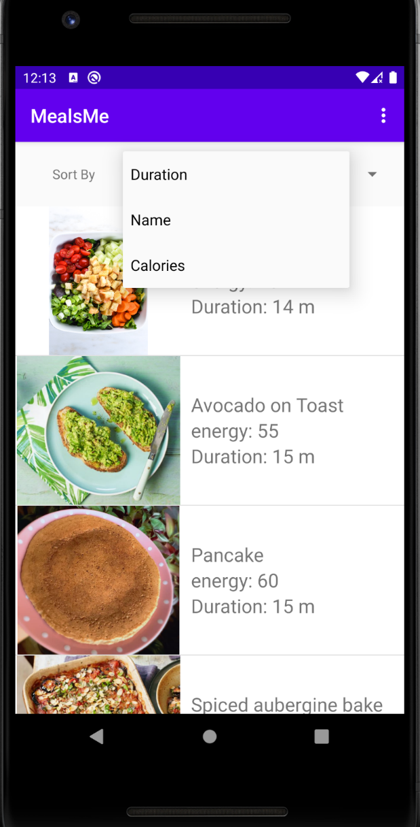

After selecting all items that you want to use for preparing your meal, You will get a list of the meals recommended for you to choose from, where these meals will have the items you selected, or at least part of it. In picture (5) you see that the screen has the functionality to sort the recommended meals based on its Duration as picture (6), name as picture (7), and calories as picture (8).

**8**

After choosing the meal you’re looking for, you will get a screen with details about how to prepare it, with scroll down function, you’ll be able to read the all text even if it is too long. Please look at picture (9)

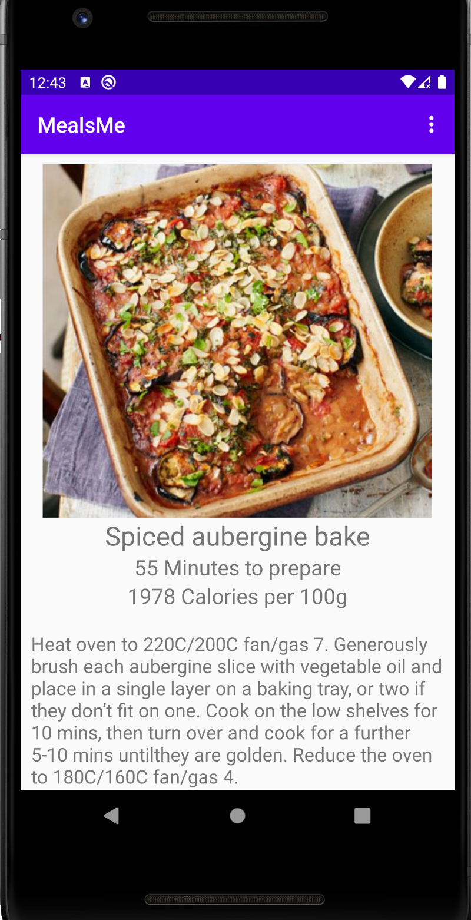

**9**

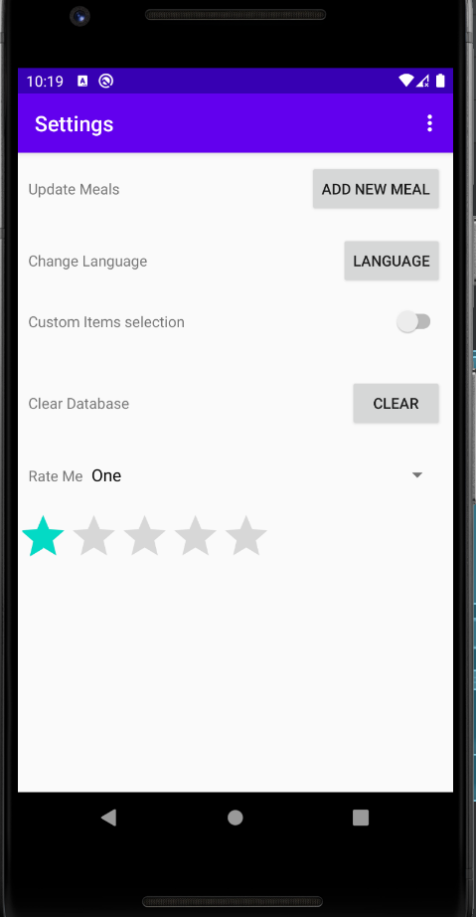when you press the menu button in the top-right of the screen, you will be able to open the settings screen, where you will find it as the picture (10) with buttons to choose from, it contains a rating scroll down spinner that can help you rate the app see picture (11), also you can clear the database, and you can choose to let all the items to be selected by default. You will be able to select another language as well, the app supports both (English and Arabic) languages, see picture (12).

**12**

**11**

**10**

**15**

**14**

**13**

When selecting the button “ADD NEW MEAL” in picture (10) in settings, you will be forward to update or add a meal, as you see in picture (13), by selecting the meal from the list, you can update the name, the description, the duration see picture (14), and also the items see picture (15). You can always press the button “Back” in your cell phone to get back to the previous screen.

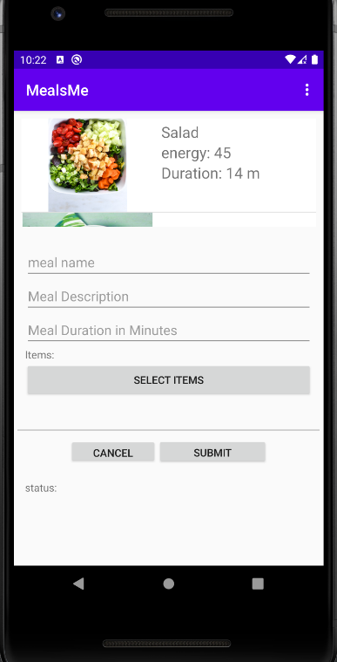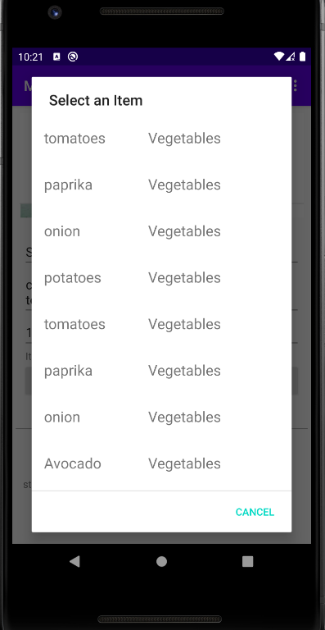

## Conclusion:

The application will be an ideal idea for making use of all items that people don’t know how to use it when it come to cooking, it gives another option not to through it away if it was extra not to know what to do with it, the data set in the application was made for viewing only, it needs a huge online data set which will be the next target.